**Play with Docker Classroom**

Time spent: 60 min

Concepts in this exercise:

* Docker engine
* Containers & images
* Image registries and Docker Store (AKA Docker Hub)
* Container isolation

**1.0 Running your first container**

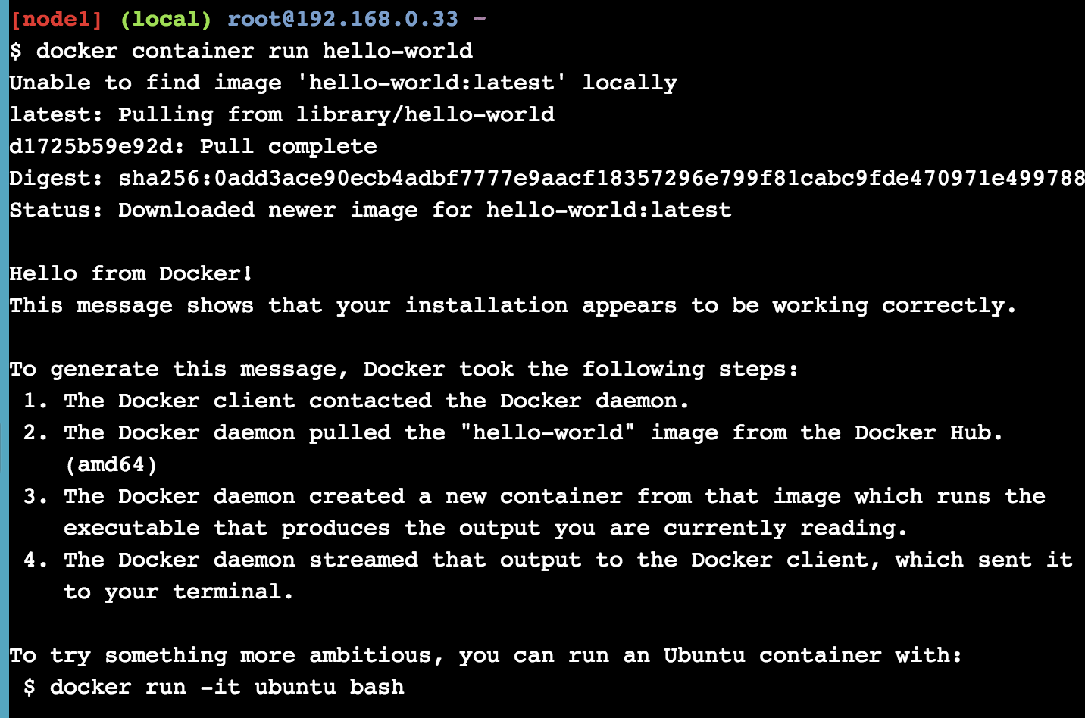

**Differences between containers and VM**

* The VM is a hardware abstraction: it takes physical CPUs and RAM from a host, and divides and shares it across several smaller virtual machines
* A container is an application abstraction: the focus is really on the OS and the application, and not so much the hardware abstraction

**1.1 Docker Images**

**Docker Container Run**

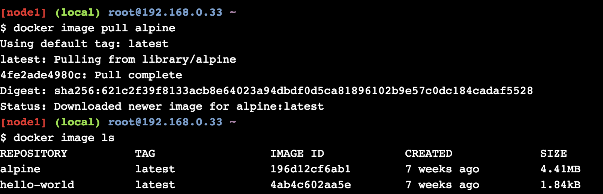

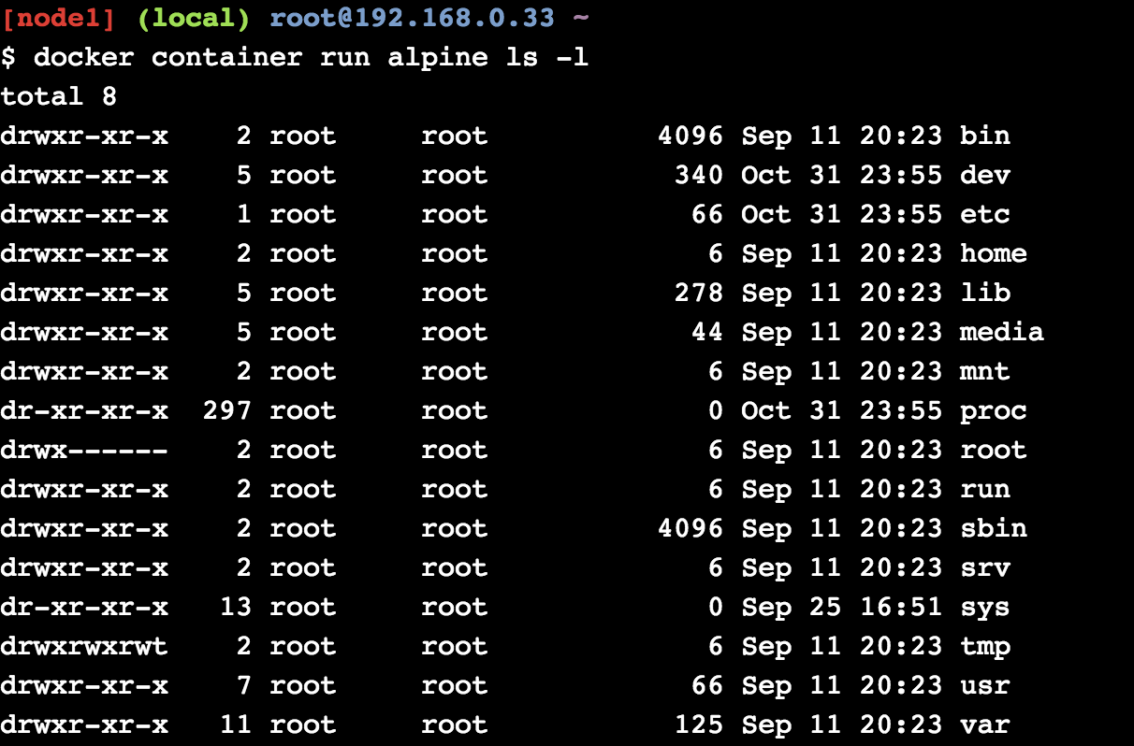

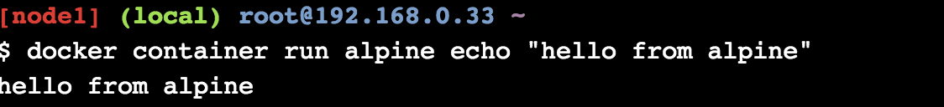

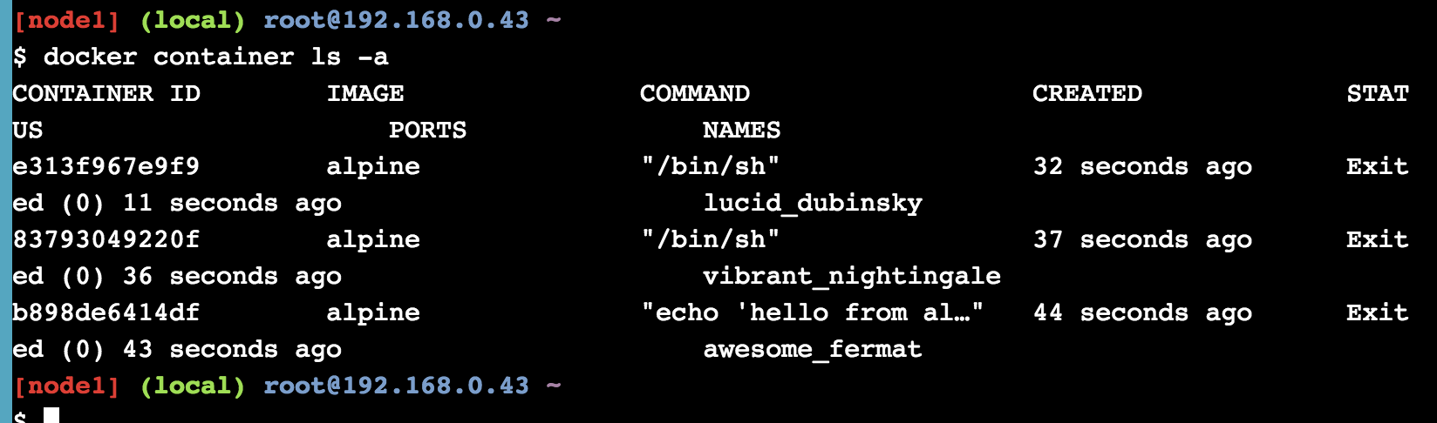

**Summary**

In this lab, I have learned how to run the container and pull the image, and I have studied the mechanism of isolation containers.